EER modelling with subclasses and super classes

ER Diagram can’t capture Specialisation / Generalisation
Enhanced Entity-Relationship (EER) Model
● an ER model with additional semantic concepts
● represented in UML
Hierarchy
A hierarchy contains of Subclasses and Superclasses
● An entity instance of a Subclass is an entity instance of a Superclass
● Subclass – a distinct sub-grouping of occurrences of an entity type
○ e.g., Manager, Sales Personnel, Secretary is a Staff
● Superclass – an entity type with distinct subclasses (e.g., Staff)
● Subtypes are related to supertypes through the “is a” relationship:
○ “Manager is a Staff” ○ “Sales Personnel is a Staff”
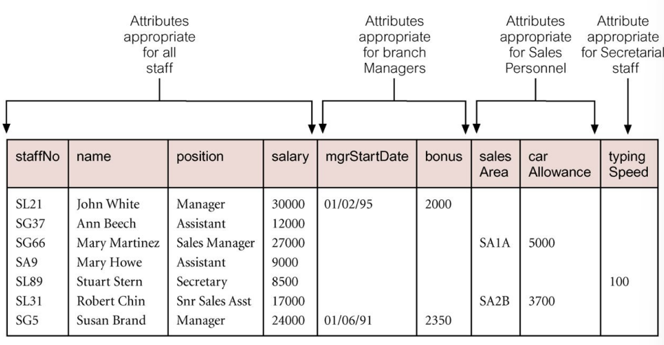
● A subclass may also have one or more subclasses

● Each subclass inherits all attributes of its superclass
● In EER diagram, inherited attributes only appear once
○ they go in the highest superclass
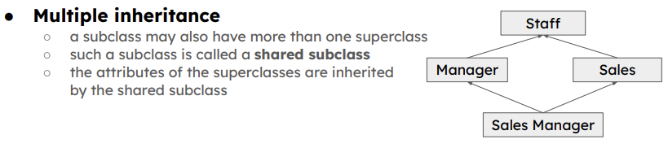
- Sub classes inherit the primary key from the superclass
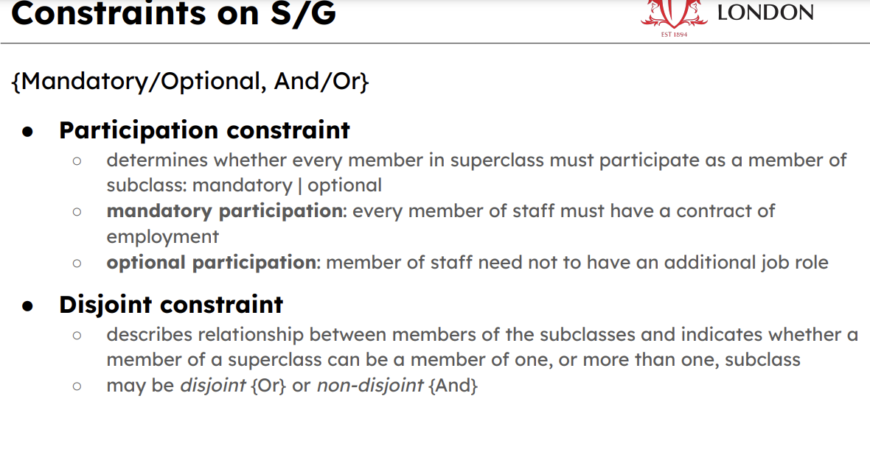
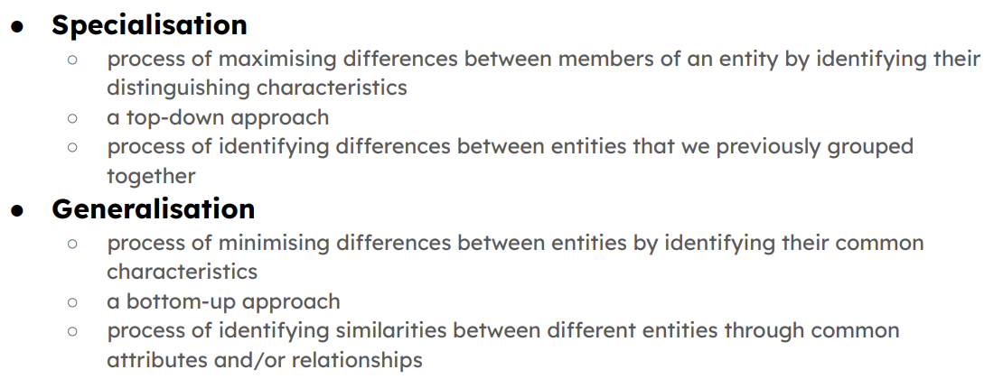

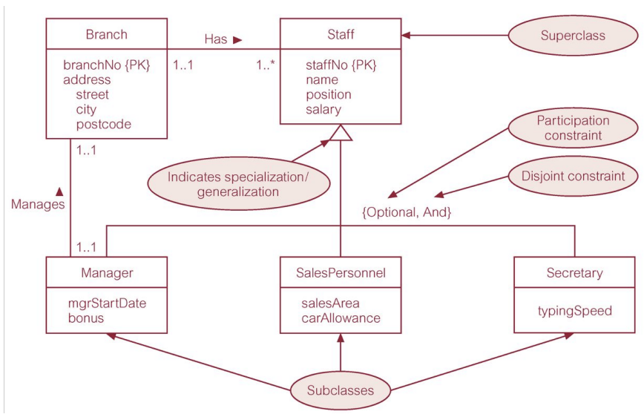

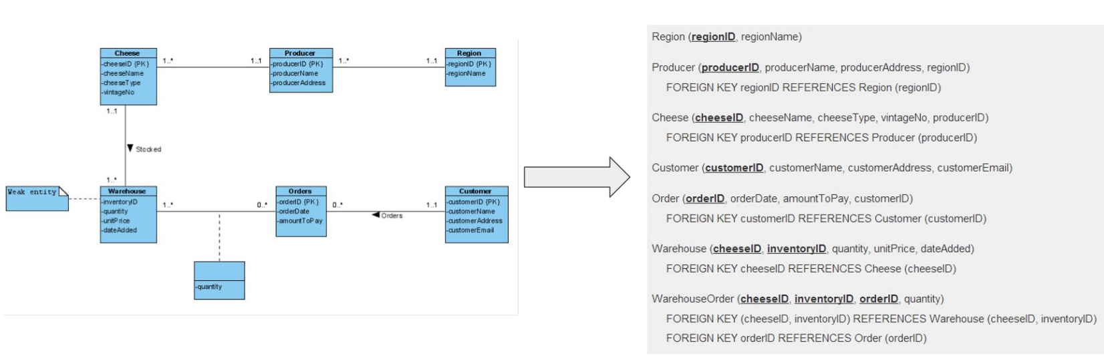
ERD to Relational MODEL
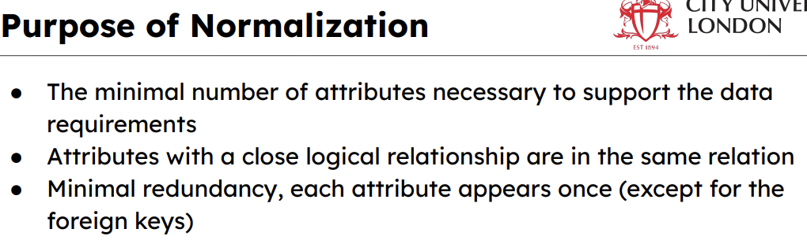

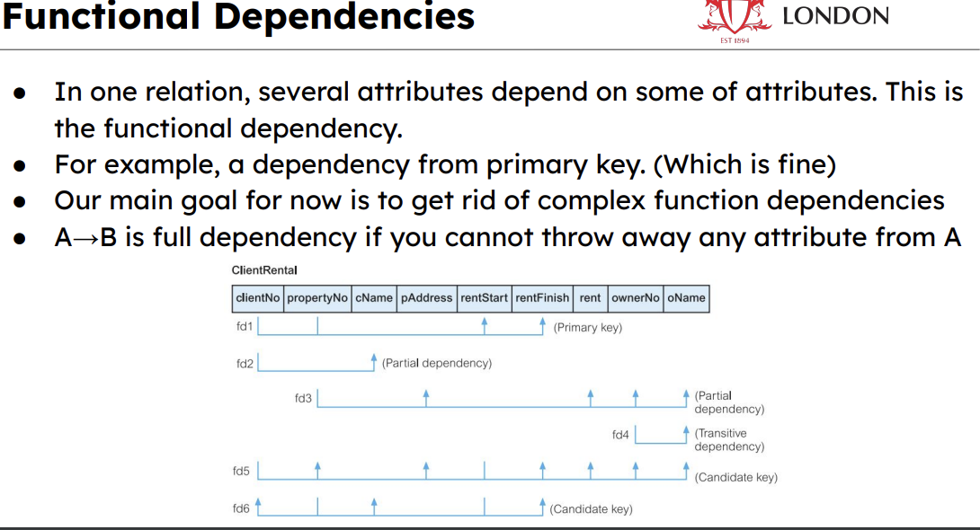

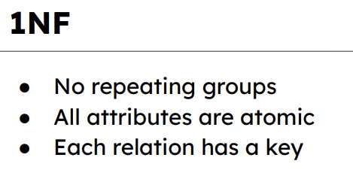
Problem with 1NF
Anomalies
● It is hard to maintain the consistency in the database if the relations are complicated ● Three types:
○ Insertion anomalies
○ Deletion anomalies
○ Modification anomalies
